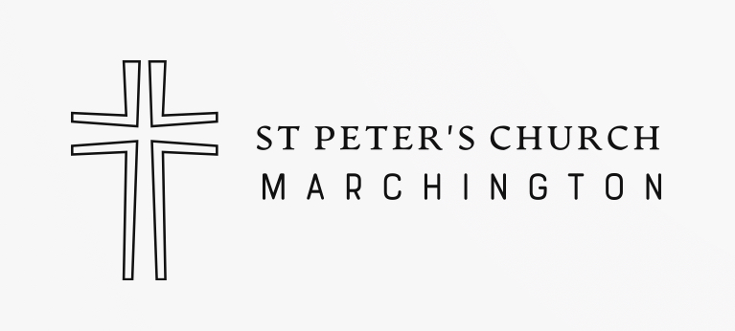

We hope you have appreciated and enjoyed worshipping in this beautiful Church. It was built in the 18th century and is one of the most prominent buildings in the village. However, it costs over £2000 every month to maintain and St Peter’s Church is not a rich one, with no big resources behind the scenes.
Most church members support our work locally through regular bank standing orders. If you are a visitor and would like to support our work, please complete this Gift Aid Donation form. If you are an eligible taxpayer, you can increase the value of your gift by 25% at no extra cost to yourself simply by filling in the Gift Aid declaration below. We can then reclaim the tax you have already paid from HMRC.
Please leave on the chest in the church or email to: stpetersmarch@gmail.com
Thank you
St Peter’s PCC, Marchington. GIFT AID DONATION 
Please print clearly
TITLE____________FULL NAME __________________________
HOUSE No./NAME
___________________________________ POSTCODE ______________
DATE_____________________
TICK I wish Gift Aid to apply to the enclosed donation. I am a UK taxpayer and understand that if I pay less Income Tax and/or Capital Gains Tax than the amount of Gift Aid claimed on all my donations in that tax year it is my responsibility to pay any difference.

